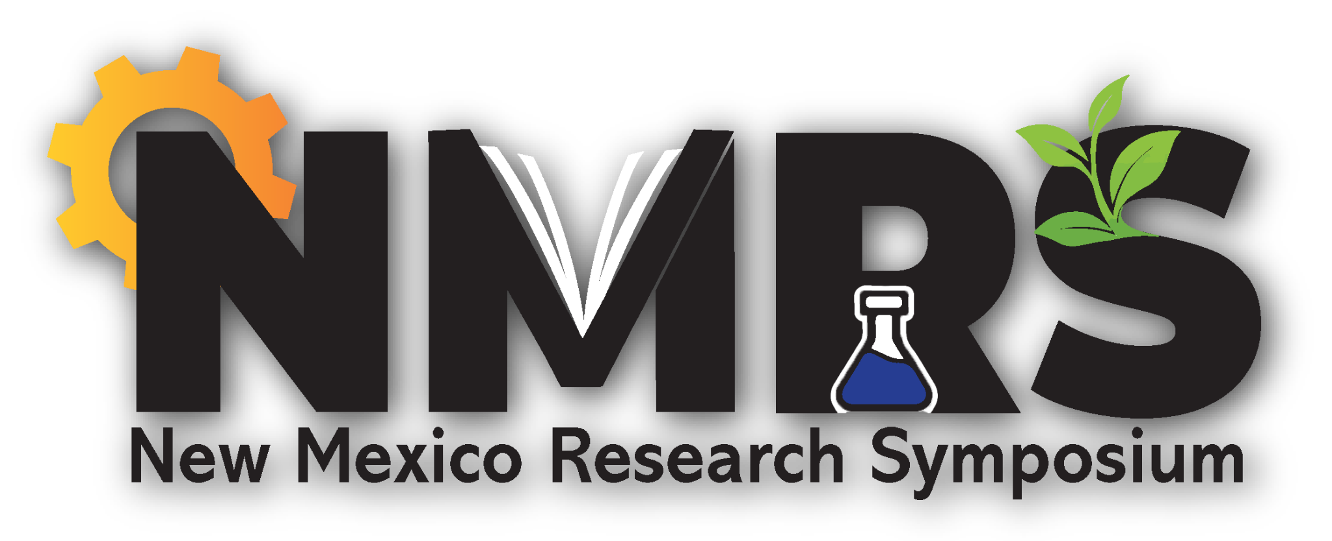Student Travel Grant Request

**Return this form to** [LAbsher@sandia.gov](mailto:LAbsher@sandia.gov); **Subject line**: NMRS Student Travel Grant

**Deadline for receipt**: Monday, September 16, 2024

**Decision on availability of support**: Monday, September 23, 2024

To help defray some of the cost for travel to participate in the 2024 NMRS, the organizers have raised support from partners to provide the opportunity for a limited number of student travel grants – many thanks for this support from Universities Research Association, The American Chemical Society Central NM Local Section, and the NM Academy of Science.

Travel one-way of greater than 100 miles will be eligible for a grant of $200; travel one-way of more than 50 miles but less than 100 miles will be eligible for a grant of $75; and travel one-way of less than 50 miles will not be eligible for a travel grant.

Please complete all the entries below and return to [NMAS@NMAS.org](mailto:NMAS@NMAS.org) no later than Monday, September 16, 2024, using the Subject line NMRS Student Travel Grant. Reviewing all the requests at that time, we will make as many awards as possible with the funds available and respond with that decision by Monday, September 23rd.

***With limited funds for travel awards available, requests will be ranked higher from students that submitted an abstract and registering and submitting requests early.***

Thanks, and we look forward to your participation in NMRS 2024!

**Full Name**:

**Your email address**:

**College or University**:

**Your year in college or graduate school**:

**Distance in miles you will travel to reach NMRS in Albuquerque** (use Google Maps to find the distance one way to the UNM Domenici Center, 1001 Stanford Dr NE, Albuquerque, NM 87131):

**Did you submit a poster or oral abstract?** – Yes or No: